Chapter 19, Solution 96

This is a fourth order network which can be realized with the network shown in Fig. (a).

L₃
1 
C₂
(a)

C₄
L₁

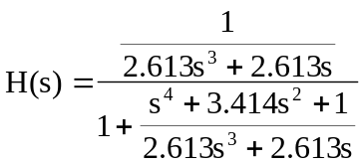

which indicates that
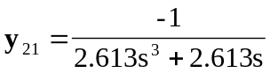
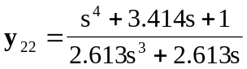

We seek to realize 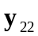. By long division,
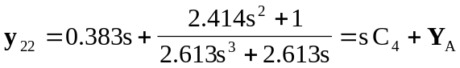

i.e. 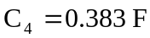 and 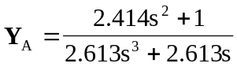
as shown in Fig. (b).
L₃
C₂
(b)

C₄
L₁
Y_{A}

y₂₂

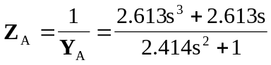

By long division,
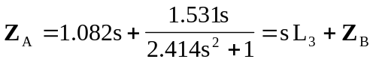

i.e. 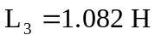 and 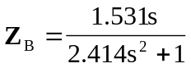
as shown in Fig.(c).
L₃
C₂
(c)

C₄
L₁
Z_{B}

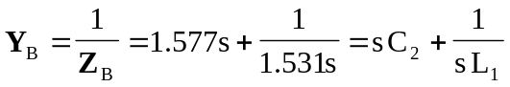

i.e. 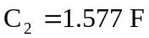 and 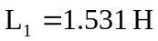

Thus, the network is shown in Fig. (d).
1.082 H
1 
0.383 F
(d)

1.531 H
1.577 F

